**EXPERIMENT 2**

**Aim :**

Develop a Calendar Application for Mobile Phone using Android Studio.

**Theory :**

We will create an android application for displaying the Calendar using CalendarView. It also provides the selection of the current date and displaying the date. The setOnDateChangeListener Interface is used which provide onSelectedDayChange method.

**onSelectedDayChange:** In this method, we get the values of days, months and years that is selected by the user.

**Requirements :**

* Android Studio
* Knowledge of XML and JAVA
* Android emulator (or) Android mobile

**Steps for Creating Calendar Application :**

***Step 1:*** Create a new project and you will have a layout XML file and Java file. Your screen will look like the image below.

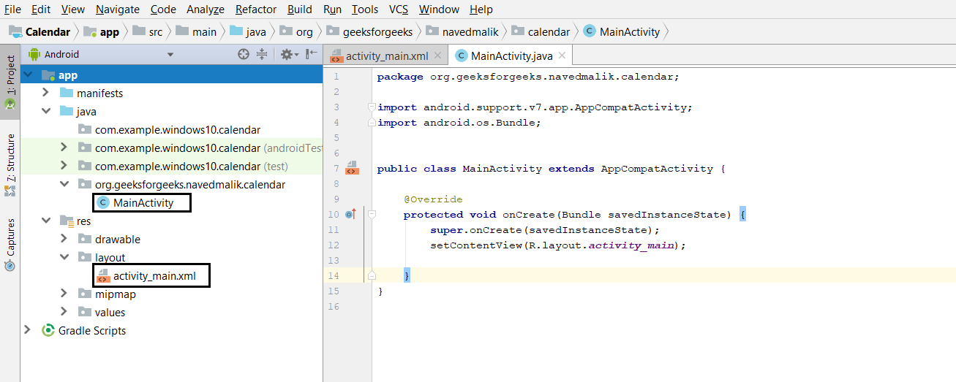

***Step 2:*** Open your XML file and add CalendarView and TextView. Assign id to TextView and CalendarView. After completing this process, the XML file screen looks like given below.

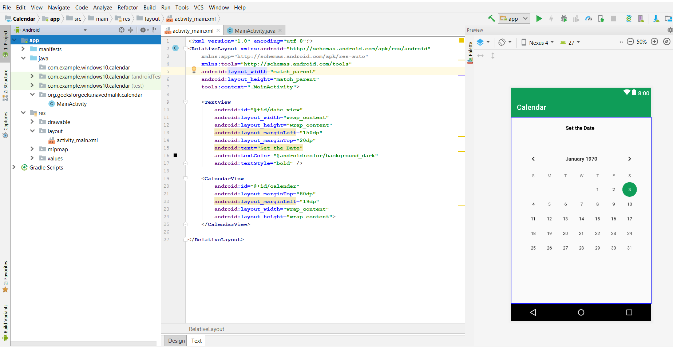

***Step 3:*** Now, open the activity java file and define the CalendarView and TextView type variable, and also use findViewById() to get the Calendarview and Textview.

***Step 4:*** Now, add setOnDateChangeListener interface in object of CalendarView which provides setOnDateChangeListener method. In this method we get the Dates (days, months, years) and set the dates in TextView for Display.

***Step 5:*** Now, run the app and set the current date which will be shown on the top of the screen.

**Code :**

**activity_main.xml** file

<?xml version="1.0" encoding="utf-8"?>

<RelativeLayout

    xmlns:android="http://schemas.android.com/apk/res/android"

    xmlns:app="http://schemas.android.com/apk/res-auto"

    xmlns:tools="http://schemas.android.com/tools"

    android:layout_width="match_parent"

    android:layout_height="match_parent"

    tools:context=".MainActivity">

    <!-- Add TextView to display the date -->

    <TextView

        android:id="@+id/date_view"

        android:layout_width="wrap_content"

        android:layout_height="wrap_content"

        android:layout_marginLeft="150dp"

        android:layout_marginTop="20dp"

        android:text="Set the Date"

        android:textColor="@android:color/background_dark"

        android:textStyle="bold" />

    <!-- Add CalenderView to display the Calender -->

    <CalendarView

        android:id="@+id/calender"

        android:layout_marginTop="80dp"

        android:layout_marginLeft="19dp"

        android:layout_width="wrap_content"

        android:layout_height="wrap_content">

    </CalendarView>

</RelativeLayout>

**MainActivity.java** file

package org.geeksforgeeks.navedmalik.calendar;

import android.support.annotation.NonNull;

import android.support.v7.app.AppCompatActivity;

import android.os.Bundle;

import android.widget.Button;

import android.widget.CalendarView;

import android.widget.TextView;

public class MainActivity extends AppCompatActivity {

    // Define the variable of CalendarView type

    // and TextView type;

    CalendarView calender;

    TextView date_view;

    @Override

    protected void onCreate(Bundle savedInstanceState)

    {

        super.onCreate(savedInstanceState);

        setContentView(R.layout.activity_main);

        // By ID we can use each component

        // which id is assign in xml file

        // use findViewById() to get the

        // CalendarView and TextView

        calender = (CalendarView)

            findViewById(R.id.calender);

        date_view = (TextView)

            findViewById(R.id.date_view);

        // Add Listener in calendar

        calender

            .setOnDateChangeListener(

                new CalendarView

                    .OnDateChangeListener() {

                        @Override

                        // In this Listener have one method

                        // and in this method we will

                        // get the value of DAYS, MONTH, YEARS

                        public void onSelectedDayChange(

                            @NonNull CalendarView view,

                            int year,

                            int month,

                            int dayOfMonth)

                        {

                            // Store the value of date with

                            // format in String type Variable

                            // Add 1 in month because month

                            // index is start with 0

                            String Date

                                = dayOfMonth + "-"

                                + (month + 1) + "-" + year;

                            // set this date in TextView for Display

                            date_view.setText(Date);

                        }

                    });

    }

}

**Output :**

